

**Build_a_Employee_Travel_Approval_  
Application_for_corporates**

1. **INTRODUCTION** 
   1. Overview

A system or application used to manage and monitor the procedure for authorising and scheduling business travel is known as a travel approval app. It could be used by a business to speed up the procedure for authorising and scheduling employee travel as well as tracking and managing the specifics of those journeys.

* 1. Purpose

The project's goal is to give all students who have a foundational understanding of Salesforce and are looking for a real-time project access to real-time knowledge. With the aid of this project, those professionals who work in several technologies and wished to transfer to Salesforce will also benefit. They will learn new skills that they may put on their resumes.

1. **Problem Definition & Design Thinking** 
   1. Empathy Map

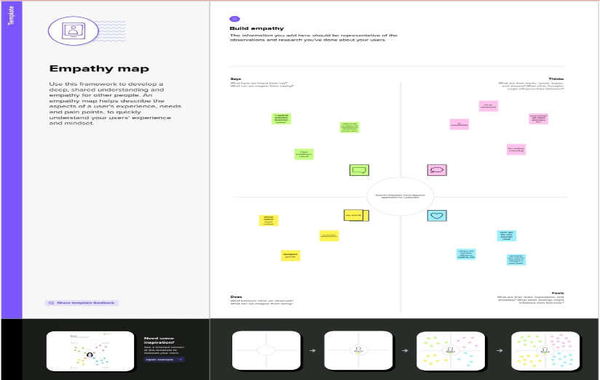

* 1. Ideation & Br0061instorming Map

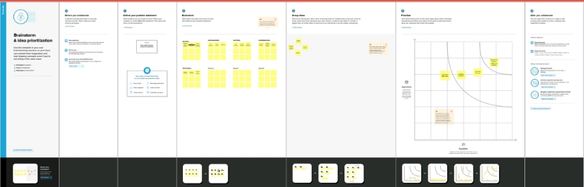

1. **RESULT** 
   1. Data Model:

|  |  |  |
| --- | --- | --- |
| **Object name** | **Fields in the Object** | |
| obj1 | Field label | Data type |
| TRAVEL APPORVAL | Field Label -  TRAVEL APPORVEL | Data type -  MASTER -DETAIL RELATIONSHIP DATA |
| obj 2 | field label | Data type |
| DEPARTMENT | field label- | Data type - |
| obj 3 | field label | Data type |
| EXPENSE ITEM | field label -EXPENES TYPE | Data type -Picklist |

* 1. Activity & Screenshot

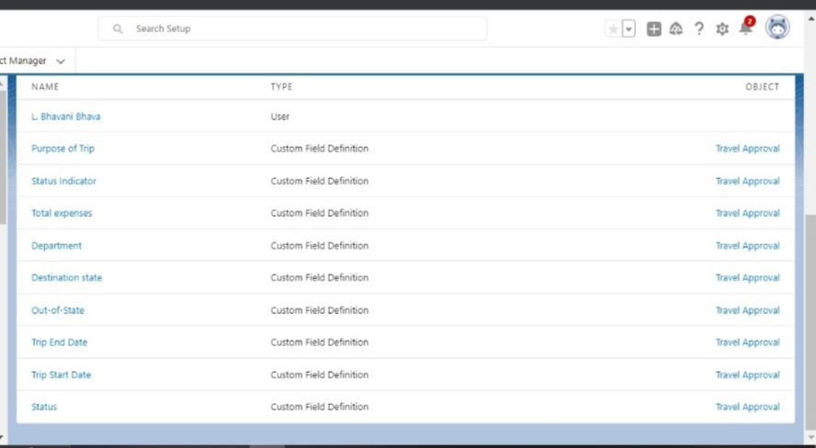

description.

1. **Trailhead Profile Public URL**

**Team Leader -https://trailblazer.me/id/kavyakutty838**

**Team Member 1 - https://trailblazer.me/id/lbhava21**

**Team Member 2 - https://trailblazer.me/id/kpushpanathan**

**Team Member 3 –https://trailblazer.me/id/lgirl6**

**Team Member 4 -https://trailblazer.me/id/suvithra**

1. **ADVANTAGES & DISADVANTAGE**

This Project helps in sending your travel approval requests to your manager in place of emails

1. **APPLICATIONS**

You can submit and approve business travel requests using the Travel Support System (TSS). The trip request can include additional external information such as car rentals or cell phone costs in addition to flights and accommodations.

1. **CONCLUSION**

By the end of the project, creating a travel approval app that provides a view of specific travel-related objects, which create in the next steps. Remember that a Salesforce app is a grouping of tabs that give access to corresponding object data..

1. **FUTURE SCOPE**

* Each employee must submit an electronic request in the system for future travel.
* Each request includes a list of estimated expenses for airfare, hotel, rental car, and so on.
* Each request must be approved by the employee’s manager, and all out-of-state travel must be approved by a travel coordinator.